The Ray Alburn Memorial Scholarship Fund

Alamo r
Ali• sr
Nm•s imam
OIL •• 0 MIMM
A partner project between Performing Arts Association of St. Joseph, 'fhe Ray Album Big Band, under the
direction of Kathleen Holeman, and the Album Family.
Application Process
Successful applicants to the Ray Album Memorial Scholarship Fund will be graduating seniors with plans to pursue higher education in music or music education. Applicants need to submit a completed application form, work sample, and recommendation by their music instructor.
Application packets must be submitted to Performing Arts Association office at 719 Edmond Street in St. Joseph, next to the Missouri Theatre, no later than the last Monday, May 10 for awards announced in mid-May.
Determination of Awards
Scholarship recipients will be selected on an objective and competitive basis considering academic and nonacademic factors.
Notification and Payment of Awards
Recipients of the scholarship will be notified in writing of their award in May. Payments will be mailed directly to the recipient's school financial aid office in October of the school year following notification.
Questions
Please refer inquiries to
Beth Sharp
Associate Director
Performing Arts Association
816-279-1225

APPLICATION
COLLEGE/SCHOOL INFORMATION — Even if you arc undecided, please list your top choice. If you have applied at more than one institution, please list your other choices on the back of this sheet.
College/School
College Mailing Address
City/State/Zip
4 yr College/University Community College Other
I lave you been accepted? Yes Not yet
If yes, please include a copy of acceptance letter.
Intended major
Student will live 0n Campus Off Campus Will Commute
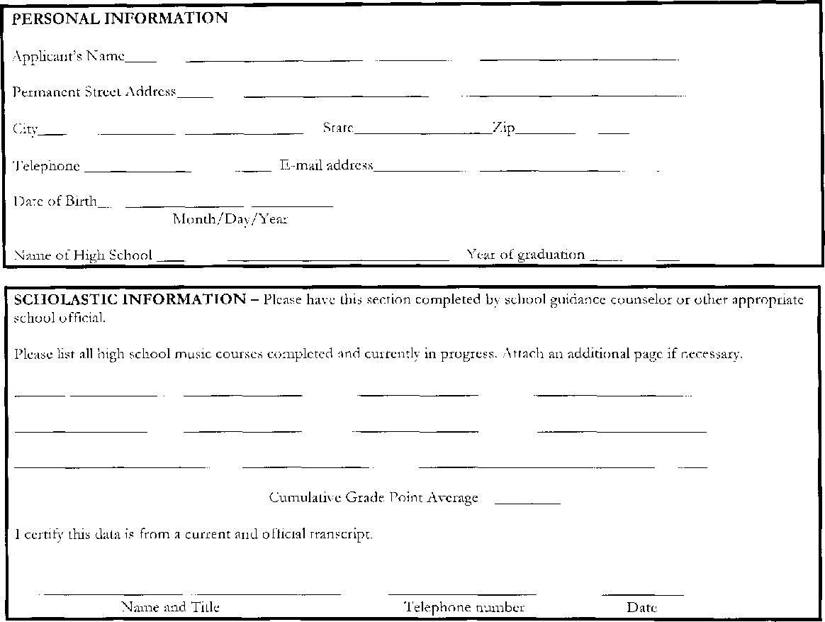
Zip
State
Telephone number
Date
Name and Title
PERSONAL INFORMATION
Applicant's Name
Permanent Street Address
City
Telephone E-mail address
Date of Birth
Month/Day/Year
Name of High School Year of graduation
SCHOLASTIC INFORMATION — Please have this section completed by school guidance counselor or other appropriate school
Please list all high school music courses completed and currently in progress. Attach an additional page if necessary.
Cumulative Grade Point Average
I certify this data is from a current and official transcript.

OTHER SCHOLARSHIPS — Please list all other scholarships pending or awarded. Attach and additional page if necessary. Name of Scholarship/Award Amount Granted or Pending
ATTACHMENTS:
HIGH SCHOOL ACTIVITIES — Please attach ONE PAGE listing school and extracurricular activities in which you have participated during the high school and any honors or awards received. You may include clubs, sports, work and church. Be sure to include your music activities such as ensembles and awards, particularly music contest awards at the regional and state level and all-conference or all-state participation.
PERFORMANCE SAMPLE — Please submit a recording of your performance of at least two pieces. Recording may be DVD, VHS Tape, or CD. Label your recording with your name, the name of the piece, and the instrument played. This recording must be of a solo performance, not an ensemble (unless the work demonstrates the applicant's particular abilities, for example: drummer or soloist in a jazz ensemble).
INSTRUCTOR RECOMMENDATION — Please obtain a letter of recommendation from your MUSIC instructor. The letter should highlight your talents and history of instruction with the teacher.
CERTIFICATION
I hereby certify that the information submitted in this application is complete and true to the best of my knowledge.
APPLICANT'S SIGNATURE DATE
SIGNATURE OF PARENT/GUARDIAN DATE
Completed application must be received by Monday, May 10, 2010for consideration.
Mail or Deliver Application Packet to
PERFORMING ARTS ASSOCIATION
719 EDMOND STREET
ST. JOSEPH, MO 64501

